
LESSON OF THE DAY

Writing a Short Biography with Obituaries
In this lesson, we invite students to learn about obituary writing in The New York Times, and then write about someone who led an interesting life, using the format of an obituary.

By Erica Ackerberg
May 23, 2022

Lesson Overview
Featured Section: Obituaries
When the reporter Margalit Fox retired, she reflected on her career as an obituary writer at The New York Times: “Writing daily obits only reinforced what I had long suspected: It is the best beat in journalism. The reason is simple: In following their subjects from cradle to grave, obits are the most narrative genre in any daily paper. For a writer, there is little better than being paid to tell stories.”
Since 1851, hundreds of thousands of obituaries have appeared in The Times. In the most basic sense, an obituary is an announcement of someone’s death. But each one is also a life story: It highlights the impact a person had on the world and what made him or her special. Those you’ll see in the pages of The Times are usually of famous people, such as Hank Aaron or Betty White, but you’ll also find obituaries of lesser known, but otherwise newsworthy, people, like Betty King, who worked backstage at Carnegie Hall, and André Cassagnes, the inventor of the Etch A Sketch.
In this lesson, you will read some of the obituaries published in The New York Times to find out what they’re like, what kinds of information they typically include and how they are written. Then, you’ll research and write an obituary for someone who led an interesting life.
Curriculum Connections
Teachers, writing an obituary can help your students practice essential research, writing and storytelling skills. You can have them write obituaries for people they knew, notable figures or anyone else whose life story is worth knowing. Here are a few ideas for different subject areas:
- An English teacher might have students write an obituary for a character from a shared class text to better understand who that person was, what was important to him or her and what effect he or she had on others in the book. Students could also write obituaries for authors or other important people from your curriculum.
- A social studies teacher could do the same with a historical figure. A math or science teacher might pick an influential person from a field of study students are learning about.
- Health or advisory teachers could use this lesson to talk about ways to remember and memorialize those who have died. They might engage students in discussion on how different cultures honor the dead.

Warm Up
Watch this trailer for a documentary about the Obituaries desk of The New York Times, and think about the following questions:
- What does it mean that obituaries are a way “to make the dead live again”?
- Does writing or reading about someone who has died feel depressing to you, or even creepy? Or, as with these obituary writers, do you find it intriguing?
- Is there anyone whose life story you would like to tell? What made that person’s life special or meaningful?

Texts
Pick one of these obituaries to read. Or search through the Obituaries section to find one that interests you.
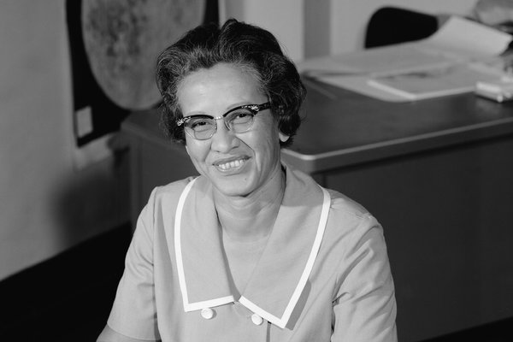

Katherine Johnson Dies at 101; Mathematician Broke Barriers at NASA
She was one of a group of black women mathematicians at NASA and its predecessor who were celebrated in the 2016 movie “Hidden Figures.”
Feb. 24, 2020

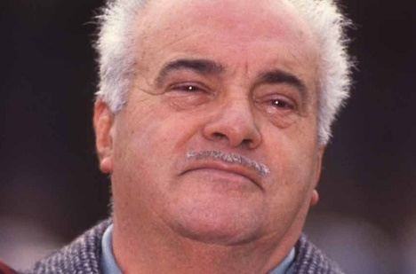
André Cassagnes, Etch A Sketch Inventor, Is Dead at 86
A chance inspiration involving metal particles and the tip of a pencil led Mr. Cassagnes to develop Etch A Sketch in the late 1950s.
Feb. 3, 2013

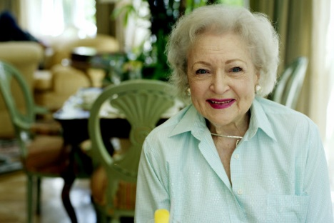
Betty White, a Television Golden Girl From the Start, Is Dead at 99
Among the many highlights of a career that began in 1949 were star turns on “The Mary Tyler Moore Show” in the 1970s and “Saturday Night Live” in 2010.
Dec. 31, 2021

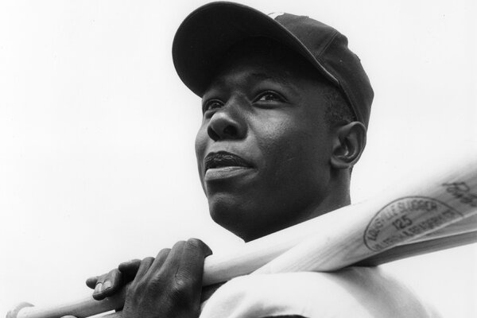
Hank Aaron, Home Run King Who Defied Racism, Dies at 86
He held the most celebrated record in sports for more than 30 years.
Jan. 22, 2021

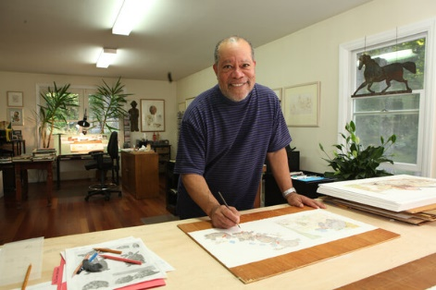
Jerry Pinkney, Acclaimed Children’s Book Illustrator, Dies at 81
Adept at reimagining classic tales, he often made sure that his books included Black characters and themes.
Oct. 21, 2021

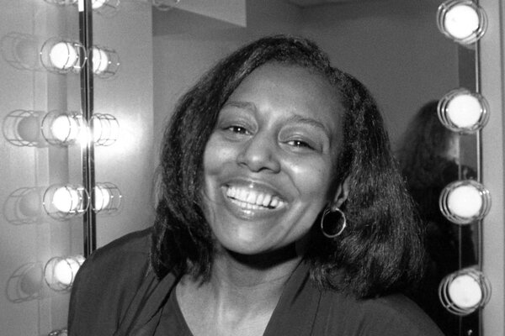
Debby King, 71, Backstage Aide Known as ‘Soul of Carnegie Hall,’ Dies
From Sinatra to Isaac Stern to Sting, she attended to the needs of the star performers in the Maestro Suite and helped calm their nerves.
Oct. 5, 2021

Questions for Writing and Discussion
Read the obituary you chose, and then answer the following questions:
1. What, if anything, did you know about this person before you read his or her obituary?
2. List some basic facts about the person: Where and when was he or she born? Who was in his or her family? What did this person accomplish in life? When and how did he or she die?
3. Why do you think The New York Times wrote an obituary about this person? What made this person newsworthy? How was his or her life special?
4. Was there anything about the person’s life that surprised you? What detail did you find most interesting? Why?
5. What, if anything, do you find inspirational about the person’s story?
6. Now, read the obituary as a writer. What do you admire about the way this piece was written? What is your favorite line, and why?

Going Further
Now, it’s your turn: Write an obituary for someone — perhaps someone you knew personally, a historical figure you are learning about in school, a character from a novel you are reading or anyone else whose life story you’d like to tell.
1. First, you’ll need to do research. You might read newspaper articles or biographies, watch or listen to interviews featuring your subject, or talk with the person’s family members or friends.
(If you’re speaking with someone whose loved one has recently died, remember to approach the conversation with compassion. When Neil Vigdor, a Times reporter, calls someone who has lost a family member or a friend, he starts by saying, “I’m deeply sorry to be reaching out under these circumstances.” Then he asks to hear more about the person who died.)
2. Next, you’ll need to identify the most basic facts of the person’s life and death. Here is part of a tip sheet from The Times’s Obituaries desk on the essential information every obituary should include:
Date of death
Place of death
Age at death
Cause of death
Full birth name, and place and date of birth
Education
Military service
Marriages, to whom and when; and divorces, if there are any.
Names of parents, siblings, spouse or companion and children. Numbers of grandchildren and great-grandchildren.
The more biographical background the obituary can give, the better. For example, how did they start their careers? Details like education and military service should be given when relevant or interesting. If possible, give the names and occupations of the subject’s parents, as well as his or her place and date of birth.
But you don’t want your obituary to just be a list of dry facts. Add what journalists call “color.” What made this person’s life interesting? In “How to Write an Obituary,” Malia Wollan interviews Victoria Chang, a poet who wrote obituary poems after her mother died, and gives examples of these kinds of details:
“Everyone is special and quirky, and I think the best obituaries capture the essence of those qualities about each of us,” Chang says. What things did she collect? What did she love to eat? What brought her joy?
3. Finally, it’s time to write. The format of an obituary is often uniform. Ms. Wollan describes it this way:
An obituary tends to have three distinct parts: the beginning (name, age, date of death, cause of death [if possible to include], work, education); the middle (anecdotes that celebrate the person’s life); and the end (so-and-so is survived by, which Chang calls “a very efficient way of saying who’s grieving.”)
Also, consider the tone you want your obituary to have. Ms. Wollan continues:
An obituary is for the living, but you should consider the sensibilities of the deceased. How would the person want to be remembered? “Imagine what they would write about themselves,” Chang says. It’s OK to be funny. “There’s a lot of humor and oddity, strange tensions and funny stuff about people and the things they do together,” Chang says.
And if you want to get creative, instead of writing a traditional obituary, make a slide show of the person’s life with photos and text, put together a mixed media collage or write an obituary poem, as Ms. Chang did for her mother. Share what you make with your class.

